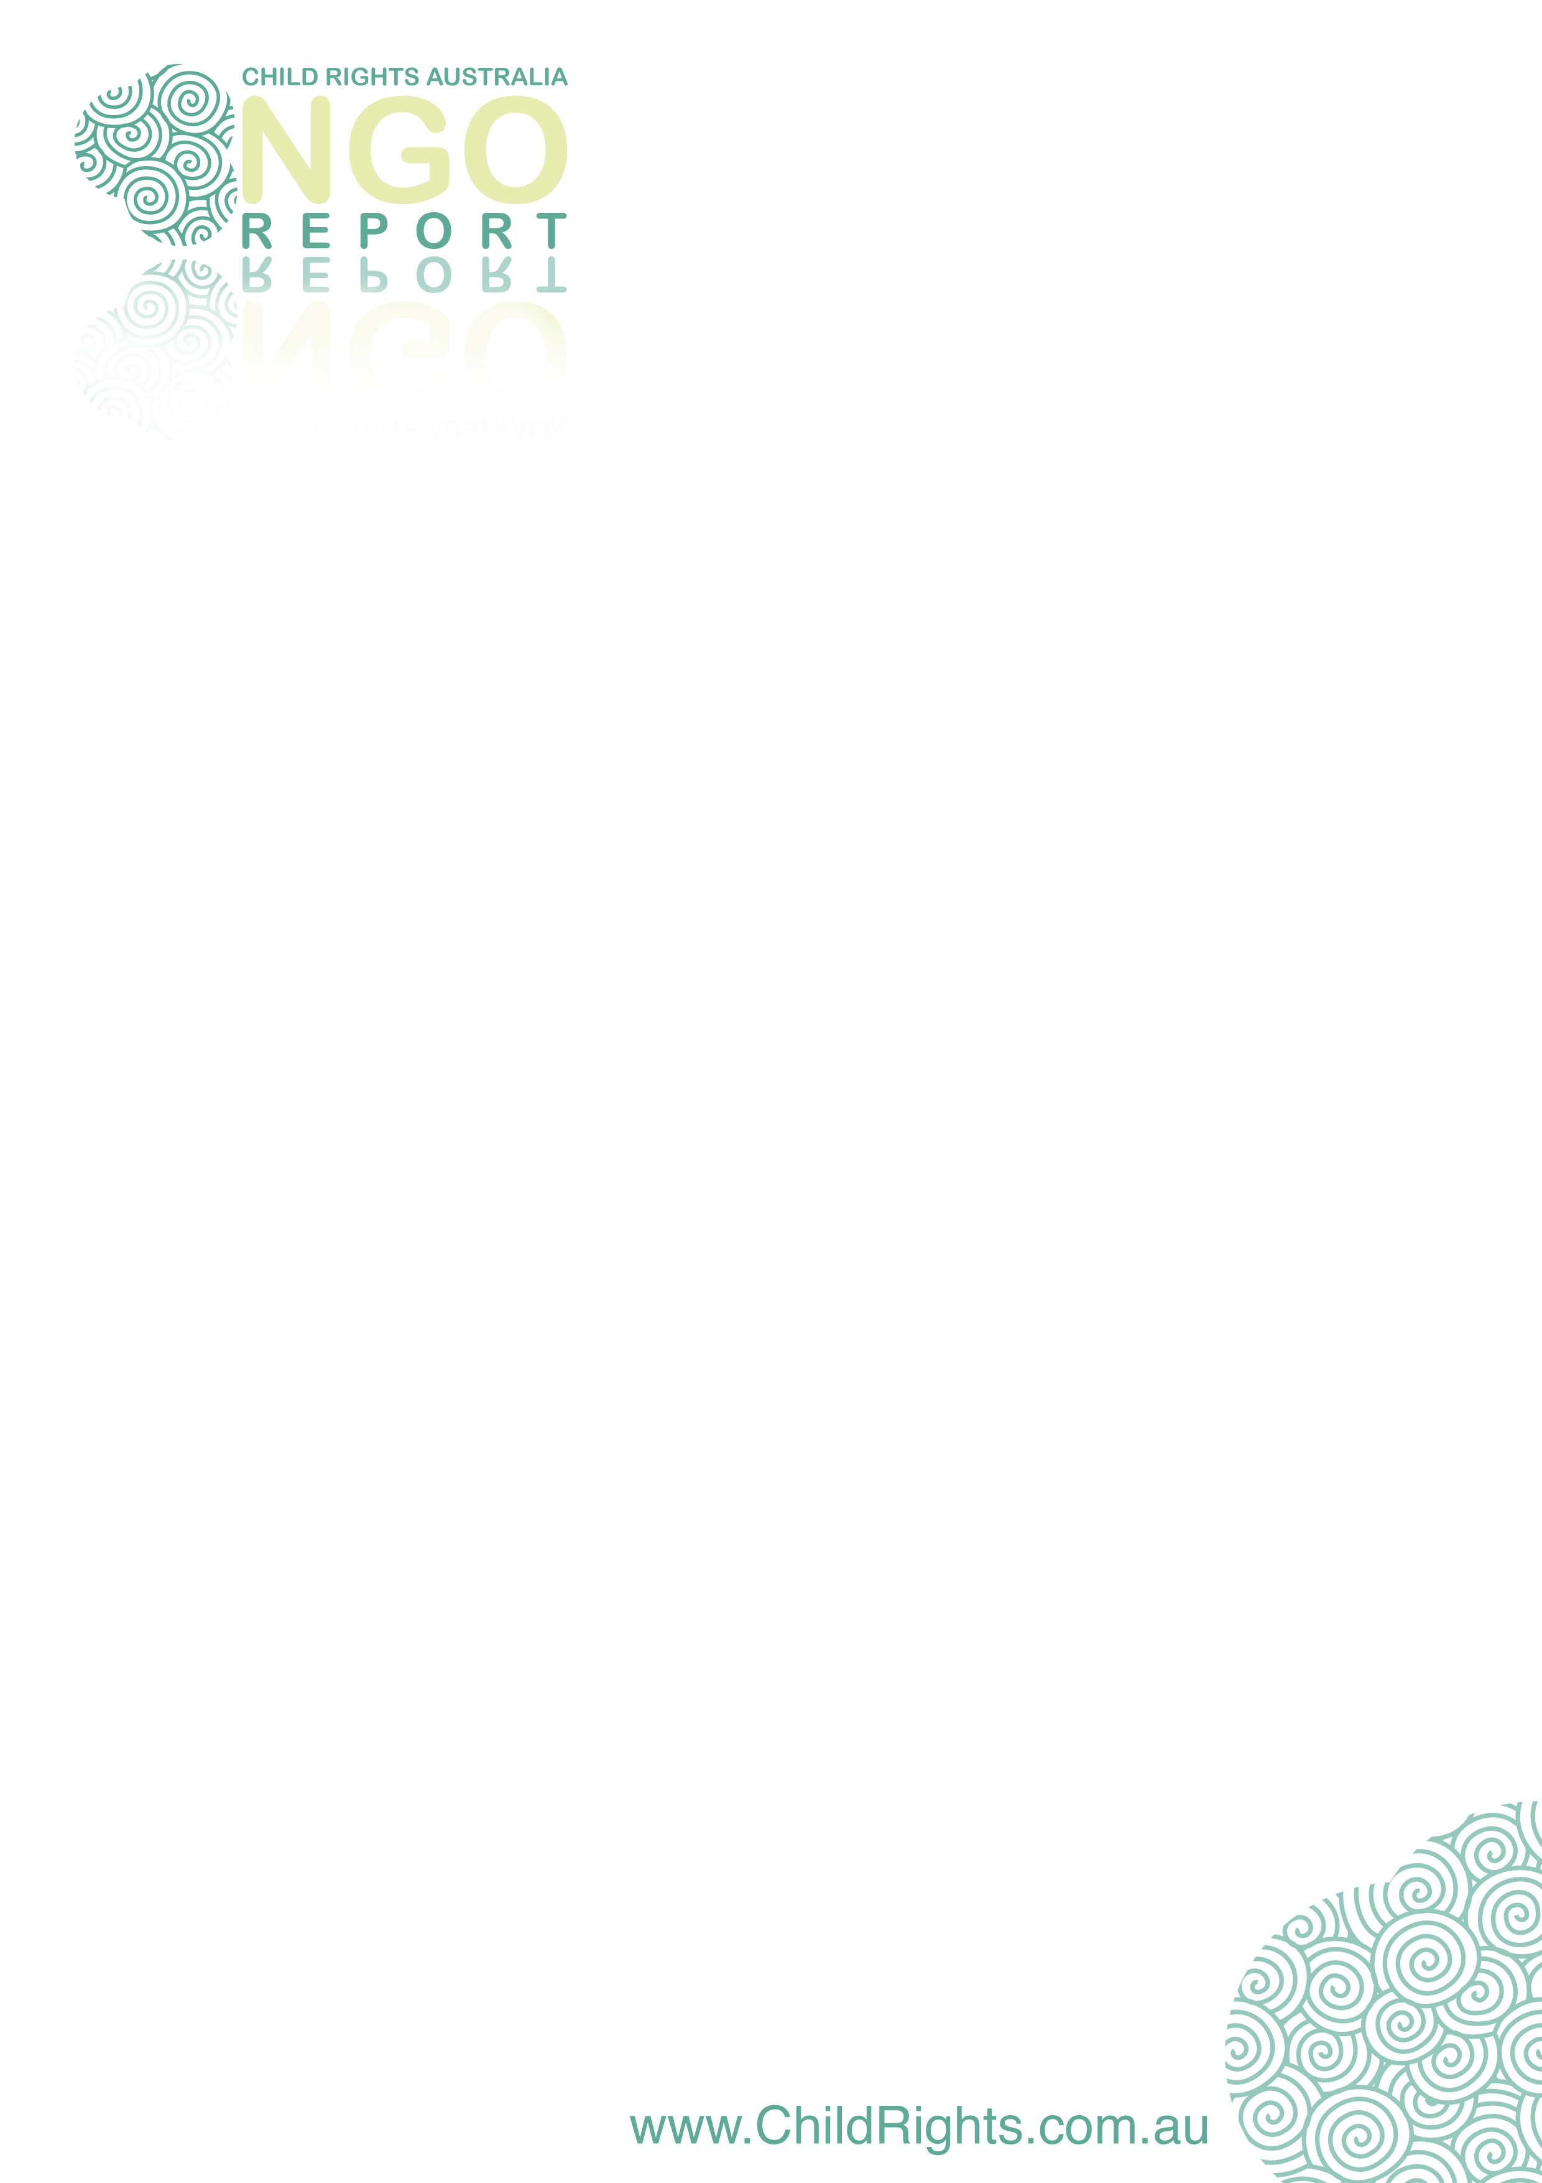

The United Nations wants to know about how Australia protects and provides for its children

Do you have any information on these or other issues affecting children?

children’s rights and freedoms
children’s participation in decision-making
respect for the views of children
the plight of indigenous children
youth justice
children and the family and alternative care
protecting children from violence and abuse
children’s health, including mental health
children with disabilities
children’s education and development
children’s standard of living
immigration and the treatment of refugee children
child trafficking, prostitution and pornography
the treatment of former child soldiers in Australia

NGO reporting to the UN Committee on the Rights of the Child
Non Government Organisations that work with children and young people in Australia can report to the United Nations on whether Australia is meeting its obligations under the Convention on the Rights of the Child (CROC).
CROC is an international treaty that Australia signed in 1990. The treaty sets out a broad range of rights for children. These include everything from the right of a child to have their views heard, to a right to an adequate standard of living. CROC covers all of the issues that are listed above.
Because CROC is in force in Australia, the Australian Government has an obligation to regularly report to the United Nations Committee on the Rights of the Child (UN Committee) on whether it is complying with CROC. The Government submitted its fourth report in June 2009, and now it’s our turn.
The Child Rights Taskforce, a coalition of organisations committed to the development of child rights in Australia, is preparing an NGO Report to the UN Committee. The Taskforce is jointly convened by UNICEF Australia and the National Children’s and Youth Law Centre (NCYLC).
The issues, ideas and recommendations that are included in our NGO Report will be considered by the UN Committee when it assesses Australia’s performance under CROC in early 2012. The last time Australia was assessed, in 2005, many of the recommendations that the UN Committee made to the Australian Government were drawn from the last NGO Report.

What issues will be covered in our NGO Report?
The NGO Report will cover all the issues at the top of the page, with particular focus on developments since 2005. Some of the key developments that we want to consider in terms of their impact on children in Australia include:
- the Northern Territory Emergency Response and ‘Close the Gap’ policies;
- the release of the National Framework for Protecting Australia’s Children;
- the treatment of children by our immigration system; and
- the treatment of homeless young people and children in conflict with the law.

What you can do
Many of you work with, or in support of, children and young people on a daily basis. In order for the NGO Report to accurately reflect the experiences of those children, we need to hear from you.
You can contribute to the NGO Report by providing us with:

reports, evidence or other documents that deal with issues affecting children. These may include documents that you or your organisation have authored, or other documents that relate to issues of concern in your area of work;

case studies based on consultation that you have conducted with children. We would like to hear not only the negative stories, but also positive examples of where law, policy or practice is working successfully;

suggestions about current issues and follow-up questions that the UN Committee can ask the Government. Examples of the type of questions that can be asked include:

What are Australian Federal, State and Territory Governments doing to reduce the high rate of homelessness amongst children who have previously been in out-of-home care?

In what way does the Family Law system allow children to express their views in all matters affecting him or her?

What data does the Australian Government have on children with a disability in rural and Indigenous communities?

recommendations for action by the Federal Government that you would like the UN Committee to make. Think about how progress in meeting the recommendations can be measured – by the Government, the Australian community and the international community.

Timeline and further information
All submissions are required by 17 December 2010.

17 December 2010 responses to be received
28 February 2011 first draft of NGO report to be available for comment
1 July 2011 NGO Report due to Committee on the Rights of the Child
Please direct all contributions, as well as any questions about the reporting process or your contribution to the NGO Report to:
Sarah Hoff
National Children’s and Youth Law Centre
Ph: (02) 9220 1568 (Monday - Tuesday)
Ph: (02) 9385 3637 (Wednesday - Friday)
Email: Sarah.Hoff@mallesons.com

